[Progress Report] Research and fabrication of a motion mimicking hydraulic powered prosthetic arm

# Summary

Upper limb amputees are facing a significant disadvantage in activities of daily living due to the lack of capability and functionality of currently available prosthetics. As such there is a push for stronger, more robust, and versatile prosthetic limbs – characteristics that hydraulic systems are able to provide.

For this project, procurement of all necessary components is almost complete, and the groundwork for the software component has been completed. There are a few remaining pieces of equipment that are still required to obtain, and the 3D print of the prosthetic limb is in progress.

Once all the necessary components have been acquired and fabrication is completed, the project will move ahead to the next stage which involves testing and tuning, and then the final stage which includes expanding and finalising the project.

Table of Contents

Summary 1

Table of Figures 1

Introduction 2

Design Constraints 3

Work Completed 4

Fabrication 4

Structure 4

Power transmission 5

Hydraulic circuit 6

Electrical circuit 6

Procurement 7

Other 8

Software 8

Modelling 9

Work Planned 10

References 11

Appendix 12

# Table of Figures

[Figure 1 Architecture for the mechanical drive system based on [1] 4](https://d.docs.live.net/5c6cad01ee5fb88a/Documents/2018%20FYP/Progress%20Report%20v2%20Kevan.docx#_Toc515025894)

[Figure 2 Initial print (Left), Revised finger joints (Right) 4](https://d.docs.live.net/5c6cad01ee5fb88a/Documents/2018%20FYP/Progress%20Report%20v2%20Kevan.docx#_Toc515025895)

Figure 3 Self designed model (Left) vs Hanson Robotics model [25] (Right) 5

[Figure 4 Current progress with hand construction 5](https://d.docs.live.net/5c6cad01ee5fb88a/Documents/2018%20FYP/Progress%20Report%20v2%20Kevan.docx#_Toc515025897)

[Figure 5 Cylinder with potentiometer and potentiometer mount attached 5](https://d.docs.live.net/5c6cad01ee5fb88a/Documents/2018%20FYP/Progress%20Report%20v2%20Kevan.docx#_Toc515025898)

[Figure 6 Hydraulic block diagram 6](https://d.docs.live.net/5c6cad01ee5fb88a/Documents/2018%20FYP/Progress%20Report%20v2%20Kevan.docx#_Toc515025899)

[Figure 7 Simplified hydraulic schematic (Complete schematic can be found in Appendix E) 6](https://d.docs.live.net/5c6cad01ee5fb88a/Documents/2018%20FYP/Progress%20Report%20v2%20Kevan.docx#_Toc515025900)

[Figure 8 First iteration of electrical circuit 7](https://d.docs.live.net/5c6cad01ee5fb88a/Documents/2018%20FYP/Progress%20Report%20v2%20Kevan.docx#_Toc515025901)

[Figure 9 Microcontroller communications diagram 9](https://d.docs.live.net/5c6cad01ee5fb88a/Documents/2018%20FYP/Progress%20Report%20v2%20Kevan.docx#_Toc515025902)

[Figure 10 PSoC Top-Level design 9](https://d.docs.live.net/5c6cad01ee5fb88a/Documents/2018%20FYP/Progress%20Report%20v2%20Kevan.docx#_Toc515025903)

[Figure 11 Single actuator block diagram 9](https://d.docs.live.net/5c6cad01ee5fb88a/Documents/2018%20FYP/Progress%20Report%20v2%20Kevan.docx#_Toc515025904)

# Introduction

There are over one million people worldwide who have had some measure of upper limb amputation [2], with a projected one million upper-limb amputees to be living in the United States alone by the year 2050 [3]. As a result, there is a continually increasing need for functional prosthetic limbs to assist amputees with activities of daily living as well as physically demanding work.

Being able to perform activities of daily living and aesthetic design are most often seen as the two major decision-making factors when choosing whether or not to use a prosthetic [4]. However, studies have found that of these two deciding factors, high grip power, grasp versatility, resilience and power autonomy, or, functionality, is generally the dominant design parameter [4, 5]. This is due to the important part practicality and functionality play in not only being able to perform specific activities and restoring normality into a person’s life, but also improving the possibility of being reinserted into a job [6]. Additionally, a study found that of all adult amputees who were employed prior to the loss of an upper limb, of the percentage that returned to work, the lowest returning percentage were those who worked in physically demanding environments where either the prosthetic solution they were provided with was either unsuitable or too difficult to operate given their circumstances [7].

The demand for a highly functional prosthesis is supported by the adoption and rejection rates of current prosthesis. Studies have found that between 17% to 80% of people with major upper limb amputation reject the use of a prosthesis entirely because the functional advantage or cosmesis did not outweigh the inconvenience of the prosthesis [5, 6]. A recurring theme presented by amputees is the desire for enhanced strength or grasp force for both myo-electric devices [4, 6, 8] and body powered devices [9, 10]. For example, for the voluntary closing body powered prosthesis known as the Hosmer Soft Hand, patients had to exert over 131N of cable force in order to achieve a mere 15N pinch force [11]. A prosthesis powered by dielectric actuators could only achieve 35-97N output force [12], and a novel pneumatically powered soft actuator could only achieve 0.46N at 5 bar of pressure [2]. To illustrate the issue, a typical anatomically intact bicep can exert 40N-116N worth of force during flexion [12]. Thus, the need for stronger, more powerful actuators are necessary, such as those that can be offered by hydraulics.

Fluid power has the potential to generate extremely large forces with smaller and more flexible configurations. Durfee, Xia and Hsiao-Wecksler modelled micro hydraulic cylinders, and at a nominal pressure of 6.9MPa (1000psi), a single hydraulic cylinder with a mere 4mm bore can output up to 87N worth of force [1]. Furthermore, the system output is infinitely variable based on the requirements of the user. For example, if more working force is required, either the pressure of the system can be increased, or the size of the cylinders increased and vice versa. If these cylinders were to be implemented, a considerable number of them would be able to fit in the space that would otherwise be taken up by a servo array, allowing far more precise control and freedom of control over the degrees of freedom of the upper limb. If the upper limb was made anatomically correct, there would be three cylinders used for flexion of a single finger which would result in a previously unseen output force per finger than a lot of currently developing prosthetic hands.

Furthermore, Resnik and Hashim have found that weight is a significant contributor to prosthesis adoption [5, 8]. Significant musculoskeletal issues can be incurred with the use of heavy and unwieldy prostheses, such as excessive discomfort on the stump and noticeable shoulder strain, and if used for extended periods of time may transition into injuries [13, 14]. A majority of externally powered prostheses make use of electrical servo motors in order to actuate the appendages. These prostheses are generally very complex and heavy due to the need of extensive gear trains or drive train mechanisms, and in some cases the placement of a servo motor at every rotational joint [15]. For example, the Modular Prosthetic Limb developed by DEKA weighs approximately 4.8kg with its battery attached [16]. In comparison, an upper limb of a 75kg person typically weighs 3kg [14].

Hydraulic powered actuators however do not require the typical power transfer systems in order to operate [17]. It was found that for a 100W mechanical system, an electromechanical system is predicted to weigh 428g. A hydraulic system with equivalent mechanical output weight will change significantly with the pressure of the system. For example, at 0.69MPa (100psi) a 100W mechanical output system is estimated to weigh 625g, at 3.45MPa (500psi) it is estimated to weigh 125g and only 63g at 6.9MPa (1000psi) [1]. This gives significant flexibility in the design to maximise the desired weight to power ratio whilst also providing a significant weight reduction which can aid heavily in the comfort and usability of the device.

Whilst the weight of the arm is extremely important, the distribution of the weight along the arm is equally as important. Additional weight from heavy servo motors and other additional components, especially towards the extremities of the body impacts negatively to the usability of the device. Waters and Mulroy found that an additional weight of 2kg on each foot of a healthy adult results in a 30% increase in oxygen uptake, whilst over ten times that amount on the torso has little impact [18]. Extending this to the upper limb demonstrates that a poor weight distribution often provided by externally powered prostheses is often hugely detrimental to the benefits that the prostheses strive to provide. For example, the TRS i-Limb (a commercially available prosthetic hand) weighs 0.63kg with a centre of gravity that is fairly distal in comparison to an anatomically intact hand due to the location of the actuators [19]. It was found that this caused significant discomfort on the stump and noticeable shoulder strain during extended use [13].

A key advantage of fluid power is the ability of power to be transported through flexible hosing which can be snaked over moving joints and placed in locations that would otherwise be impractical for electrical motors. This characteristic provides great flexibility in component placement such as placing the hydraulic cylinders on the proximal joints [1], and the other heavier components such as the pump, valves and battery may be kept on the torso where they cause a considerably lesser strain on the body [17]. Furthermore, this flexibility can be leveraged for numerous additional benefits. By being able to choose the location of the actuators, they can be optimised for maximum benefit. Placing the actuators away from the joints of the fingers and closer to the shoulder aids in reducing the rotational inertia [16] which allows greater control over the arm and reduced power requirements in order to operate it. This also allows the end effector or the hand to be minimised to further reduce the weight [20], as a prosthetic hand weighing 0.5kg or more tends to lead to overexertion [6]. Power then can be transmitted to the distal joints via tendon or cables – a technique used often in prosthetics to gain similar benefits [21].

There is a clear need for stronger and more powerful, yet lighter and more robust prosthetic devices, which can be catered to by hydraulics. These benefits combined with its flexible component configuration as well as its force-to-weight ratio have the potential to develop a revolutionary prosthetic design. It will be another step in the direction to allow amputees and similarly disadvantaged persons to mitigate the adverse effects of upper limb loss and enable them to retain or regain their standard of living.

The aim of this project is to explore the use of hydraulics in upper limb prostheses - to identify its practicality and feasibility in the field. The goal is to rapidly prototype an anthropomorphic prosthetic arm with a high and demonstrable degree of freedom using readily available and off-the-shelf components.

## Design Constraints

The reason for developing an anthropomorphic style prosthetic arm is due to aesthetic and degree of anthropomorphism being seen as one of the most important characteristics that a prosthetic system should exhibit. Aesthetic plays a crucial role in the psychological wellbeing and social acceptance of amputees [4]. It is one of the main reasons why many amputees opt for an externally powered prosthesis, and one of the reasons why the gap of usage between powered and unpowered devices is so large [8]. Whilst it is challenging to develop an anthropomorphic and anatomically correct system based on musculoskeletal systems [6], there is no reason to develop a prosthetic system if the adoption rates will be extremely low.

Being a rapid prototyping project, the goal is to use as many off-the-shelf and ready-made components as possible. However, micro hydraulic systems tend to be expensive and not readily available. There has been research and development in the field of micro hydraulic fluids, such as a minimal weight and wearable hydraulic power supply [22] and alternative actuator designs such as soft fluid power actuators [23] or nested hydraulic cylinders [24]. These systems however are all just prototypes and thus it is not easy or affordable to obtain these for the purpose of this project. The ideal actuators to use for this prosthetic design are mesofluidic actuators such as those used in [21]. Limiting the project to what can be purchased relatively easily considerably restricts the capability and effectiveness of the prosthetic (manufacturing low tolerance actuators is slow and expensive) however it should still be sufficient to demonstrate the benefits of the design.

# Work Completed

## Fabrication

Fabrication of the prosthetic arm structure began almost immediately. Figure 1 illustrates the layout of the entire system. It has been based on [1] who developed a hydraulic system for an orthotic device.

Motion Controller

Computer

PWM Driver

Servo motor

Valve

Conduit

Cylinder

Pump

Figure Architecture for the mechanical drive system based on [1]

All components prior to the valve represent the power supply and control components. The ‘Conduit’ block represents the power transmission line, and the ‘Cylinder’ block represents the actuator.

### Structure

Initially we had opted to develop our own prosthetic arm structure so that we could optimise it for our actuation method. The model would be based off Thieme’s Atlas of Anatomy [25] which provided an in-depth insight into the structure of the upper limb. We had decided to model all 22 DoF initially, which led to an initial design seen in Figure 2. After the initial print we then determined that we would remodel the joints such that they were designed as single degree of freedom joints for ease of actuation for an initial prototype (Figure 3 left). The metacarpal bones were designed to be separate such that if we wished to implement the abduction and adduction of fingers, there would be room for the actuators in the anatomically correct locations. We determined however that achieving anatomically correct abduction and adduction would be impossible with the components we could acquire if we wished to retain complete hydraulic actuation.

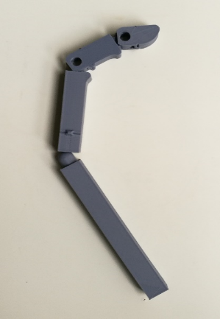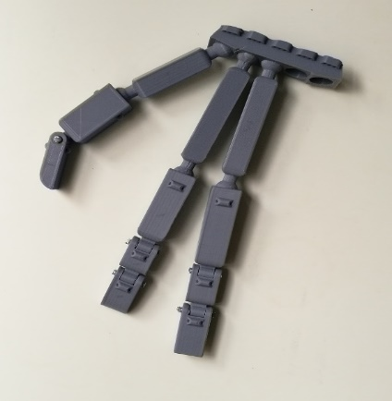

Figure Initial print (Left), Revised finger joints (Right)

After numerous hours of 3D modelling, we decided that designing our own prosthetic arm would take too much time for the project duration, and thus opted to take and adapt an externally made prosthetic arm for our actuation method (Figure 3 right). This prosthetic arm was made and developed by a company called Hanson Robotics for the Sophia Robot Project [26].

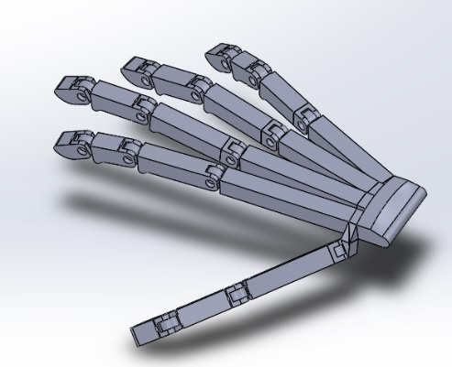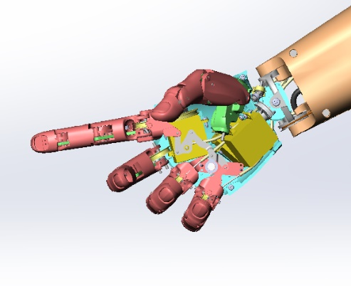

Figure Self designed model (Left) vs Hanson Robotics model [26] (Right)

Trial prints of the prosthetic hand has begun (Figure 4), and we are currently attempting to assemble the hand to better identify Hanson Robotics’s method of power transmission, and then adapt it for our own purposes. As per our project plan, we will be constructing just the index finger initially and actuating that before expanding our design.

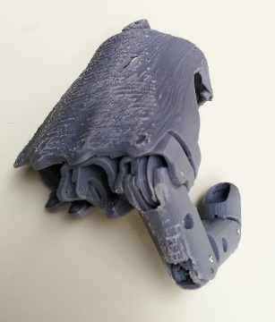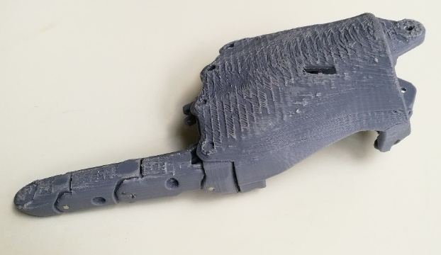

Figure Current progress with hand construction

The forearm at the moment is out of our present scope, and as such we will use an arbitrarily simple structure to mount our actuators, so that we can perform testing and tuning on our system.

In order to mount the position sensors (slide potentiometers) to each individual cylinder, a two-component mounting structure was designed. It was designed to mount directly onto the cylinders themselves to minimise the space requirements (Figure 5).

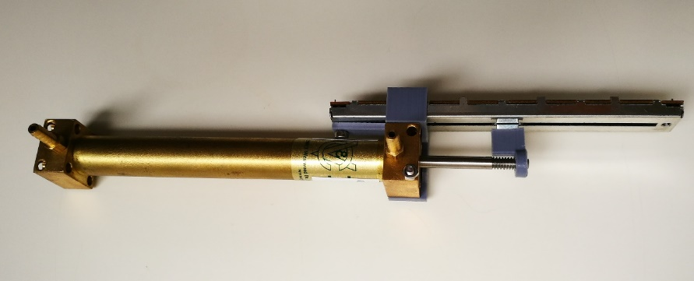

Figure Cylinder with potentiometer and potentiometer mount attached

### Power transmission

We have opted to follow Kontoudis’s recommendation in using elastomeric materials to perform digital extension, whilst using cables attached to the actuators for flexion [6]. For the cable component we have chosen to use braided steel wire which should be strong enough for the amount of tension we will be supplying to the system. Whilst it is known that there is power loss from friction for cable transmissions [10, 20], we believe that given our actuation method these losses should be insignificant for demonstrative purposes. If necessary we could employ friction reducing materials such as Teflon liners to improve the efficiency of power transfer as suggested by Hichert [10]. For the elastomeric materials component, we have decided to use torsion springs installed internally into the joints, as this has already been catered for in Hanson Robotics’s design. This will allow extension as when the actuator extends, slack appears in the cable which is picked up by the torsion springs.

### Hydraulic circuit

The hydraulic requirements for the system is very simple. It is a basic pump, actuator, and directional control valve configuration. The block diagram of this system can be found in Figure 6, a simplified schematic in Figure 7, and the complete schematic in Appendix E.

Pump

Pump

Valves

Valves

Conduit

Conduit

Cylinder

Cylinder

Figure Hydraulic block diagram

Our system is pressure limited due to the budget we have to work with. As such, the pressure limiting device is the valves which are designed to be operated at a working pressure of 18 bar, and a maximum pressure of 30 bar. Therefore, the maximum output force of the system will never be reached due to this limitation. If we can reach our theoretical maximum pressure in the cylinders, we would be able to achieve an output force of around 89N.

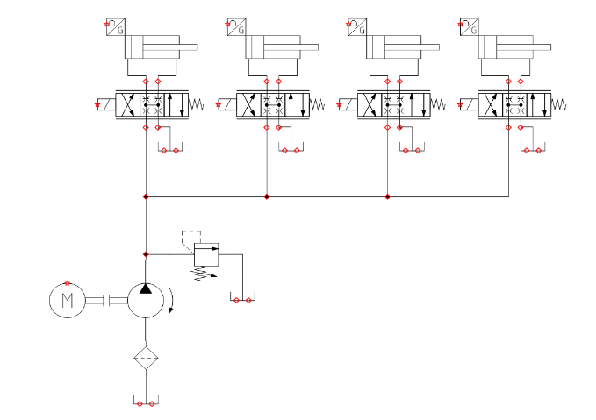

Figure Simplified hydraulic schematic (Complete schematic can be found in Appendix E)

We have completely determined all the specific components required to complete the hydraulic component of the fabrication. In particular we require 3/8” BSP Port to 4mm fittings and 4/2.5mm nylon hosing. Once these are acquired the hydraulic circuit can be completed and testing can commence.

### Electrical circuit

The original electrical circuit was designed as seen in Figure 8. This was designed with the assumption that we would be able to acquire hydraulic solenoid proportional valves, magnetic cylinder position sensors and a suitable USB to GPIO module. However, the solenoid proportional valves and magnetic cylinder position sensors were priced in such a way that we would not be able to afford a reasonable quantity for the purpose of this project, coming at around $1000 per valve and $300 per sensor. The USB to GPIO module could not satisfy the criteria we required as the maximum switching frequency would not be able to provide a suitable PWM signal for control.

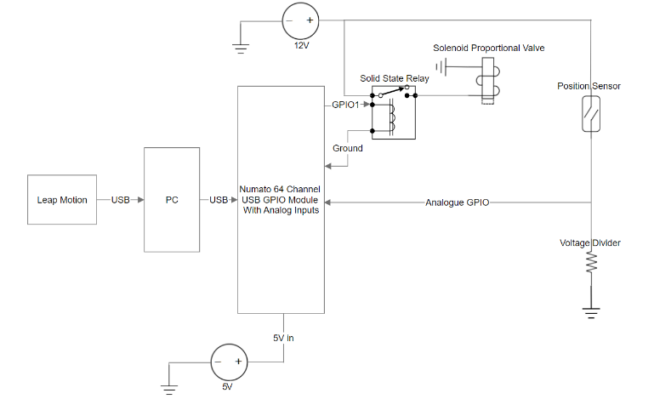

Figure First iteration of electrical circuit

Thus, we have opted for servo proportional valves, slide potentiometers and a PSoC. This slightly modifies the previous electrical circuit, and whilst cheaper, provides us with sufficient capability to control the prosthetic arm.

## Procurement

The components required to construct this prototype are as follows:

* Hydraulic power unit
* Directional control valves
* Hydraulic oil
* Hydraulic hosing and fittings
* Servo motors
* Programmable system on a chip (PSoC)
* Computer
* Leap Motion Controller
* Hydraulic cylinders
* Tendons
* Elastic elements (i.e. torsion spring or elastomeric materials)
* Position sensor
* Relays

Due to the nature of the project, the project is personally funded. This has resulted in the need to obtain affordable hydraulic components, which is generally not very possible based on the current state of the hydraulics industry. This means that relationships would need to be developed with manufacturers and distributors in order to make the project possible. We approached numerous different hydraulics companies to see whether or not arrangements could be made for either discounts or hire of the equipment we needed.

Of the companies contacted, we managed to develop beneficial relationships with three major companies: Hydac, a major hydraulic component manufacturer and distributor; Valvoline, a major oil manufacturer and distributor; and Hydraulink, a medium sized hydraulic hosing and coupling distributor. Smaller benefits were obtained from: Cylinders & Valves Incorporated, a hydraulic cylinder manufacturer; Numato Lab, an industrial control and automation manufacturer; and SICK, an industrial sensor manufacturer.

Hydac has offered to provide an entire power unit for the purpose of our project for no charge. They will be installing the power unit with a 1.1kW motor and a 50L reservoir which should be sufficient for our purposes, however as it is an industrial company, their motor will require a three-phase power supply. They are also providing four directional control valves which will reduce the cost of the project significantly. Their contribution is worth approximately $2000.

Valvoline has agreed to provide as much hydraulic oil as necessary for the purpose of this project. As of the moment we have obtained 60L of ISO 32 grade hydraulic oil at no cost to us. We have chosen ISO 32 based on the specifications of the pump to ensure the best operation for a reasonable duration. Their contribution is worth approximately $400.

Hydraulink had previously agreed to supply hosing and fittings for our project in the event that they were able to obtain the suitable components for the project. However once we have completely specified our system their state manager determined they were no longer able to assist due to the size of the conduits we required. We are currently establishing alternative methods to obtain the required hosing and fittings.

Cylinders and Valves Incorporated agreed to provide a 20% subsidy to any purchases made through them. We have purchased four 10mm bore cylinders from them, with that discount. Their discount is worth approximately $60.

Numato Labs have provided a generous discount for their products which equated to about 40%. We have purchased a USB to GPIO module with the intention to control the large valves that Hydac have provided via solid state relays. Their contribution is worth approximately $120.

SICK has offered considerable discounts on their industrial grade sensors. They have offered an approximately 40% concession on their sensors, however after some initial testing of cheap position sensors, their sensors may not entirely be necessary (refer to Appendix A). At $100-$200 per sensor after discount, a large amount of consideration must be applied before pursuing these premium sensors.

Of the remaining components, the directional control valves, servo motors, PSoC, Leap Motion Controller, steel wire, elastic elements, position sensors and relays have all been acquired.

## Other

The dangers of operating a hydraulic system has been made extremely clear to us. Hydac, as part of their contribution offered to provide an accredited and certified training course in order to educate us both about hydraulic systems and how to safely operate them free of charge. We decided to undertake this training course as we understand the safety of persons near and operating the device is of utmost concern. We are now both certified in Basic Hydraulics 1, accredited by the KANGAN institute which provides us with the skills and knowledge to operate simple hydraulic systems safely.

We have also completed the safety induction for the Laboratory for Motion Generation and Analysis, to ensure that we are aware of the safety procedures concerning the lab to ensure the safety of everyone inside the building and the lab itself.

## Software

We have decided to use GitHub as a version control and development tool through the duration of this project. All code written and developed in this project will be uploaded to GitHub [27]. This allows us to track changes, roll back code if issues develop, and have access to the code from anywhere.

The framework for using the microcontrollers in the system has been completed, establishing communications between all microcontrollers, sensors and actuators in the system. The program has been programmed in C++. It communicates between microcontrollers in a call-response manner.

Leap Motion

Leap Motion

CPU

CPU

PSoC

PSoC

Figure Microcontroller communications diagram

We have currently obtained a communications frequency of around 40Hz, that is 40 calls and responses per second. Though this limitation is software side and can be improved with optimisation.

The microcontroller purposes are as follows. The leap motion controller pulls position information from the orientation of the reference hand. This is communicated to the main computer which processes the information to determine the angle of the joints. This is compared against the current position of the joints which is detected by the PSoC. The error is then calculated by the computer and a new valve position is pushed to the PSoC.

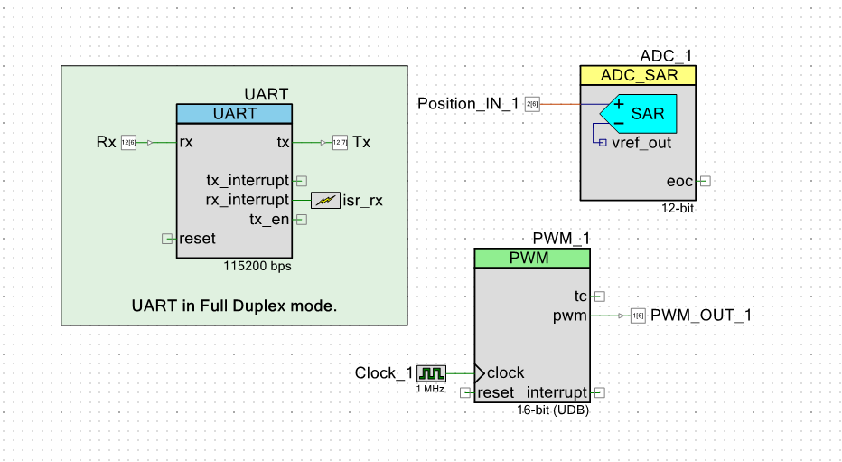

Figure PSoC Top-Level design

The PSoC code is designed to be minimal and light weight in order to achieve low latency response times. The top-level design is seen in Figure 10 which illustrates this as there are only three major components programmed.

### Modelling

Preliminary steps for modelling the system has begun. The block diagram for a system with a single actuator is illustrated in Figure 11.

Figure Single actuator block diagram

1/s

1/s

Where:

The PID controller is defined by:

The plant formula uses the assumption that the system will maintain constant pressure and uses the following formulas:

Where:

The position to joint angle converter currently only has a fill in variable which represents the relationship between the two variables. This will have to be calculated after fabrication of the relevant joints are completed. It will be different for every joint.

# Work Planned

The overall outcomes for this project are to build a controllable prosthetic arm using hydraulic actuation which mimics a person’s hand with data from a LEAP motion controller. Going forward, acquisition of all components needs to be prioritised as currently this is causing a delay in the project. Appendix B and C show that the lack of a working system is hindering the progress of Stage 2. Missing components include hosing, coupling and the pump. Once these parts are acquired the system will be assembled, and Stage 2 can be quickly completed as the groundwork for Stage 2 has already been completed. Thus, it can be expected that work can commence on Stages 3 (Appendix C) and 4 (Appendix D) relatively soon.

Continued delays for this project can be caused by further issues procuring components, as working with external companies can cause significant delays as providing assistance free of charge often ranks extremely low on their priority lists.

Possible causes of failure are if the pump or proportional valves are unable to supply the necessary amount of pressure and actuation speed required to keep up with the reference input, or, previously unforeseen issues with the reference information from the motion controller. This may force a re-evaluation of the project scope in order to match what is achievable with the available equipment.

The focus after we have obtained all components will be to begin tuning the controller for the actuators for an ideal response, i.e. zero overshoot and fast rise time and setting time. Tuning will begin with the Ziegler-Nichols tuning method as well as a separate theory-based model based on the control system we identify in Figure 11. Using a combination of theory and experimental methods to tune the PID should hasten the process.

# References

1. Durfee, W., J. Xia, and E. Hsiao-Wecksler. *Tiny hydraulics for powered orthotics*. in *2011 IEEE International Conference on Rehabilitation Robotics*. 2011.

2. Mata Amritanandamayi, D., G. Udupa, and P. Sreedharan, *A novel underactuated multi-fingered soft robotic hand for prosthetic application.* Robotics and Autonomous Systems, 2018. **100**: p. 267-277.

3. Perry, B.N., et al., *Initial Clinical Evaluation of the Modular Prosthetic Limb.* Frontiers in Neurology, 2018.

4. Piazza, C., et al., *The SoftHand Pro-H: A Hybrid Body-Controlled, Electrically Powered Hand Prosthesis for Daily Living and Working.* IEEE Robotics and Automation Magazine, 2017. **24**(4): p. 87-101.

5. Resnik, L. and S. Klinger, *Attrition and retention in upper limb prosthetics research: experience of the VA home study of the DEKA arm.* Disability and Rehabilitation: Assistive Technology, 2017. **12**(8): p. 816-821.

6. Proaño-Guevara, D., et al. *Biomimetical Arm Prosthesis: A New Proposal*. 2018. Cham: Springer International Publishing.

7. Millstein, S., D. Bain, and G.A. Hunter, *A review of employment patterns of industrial amputees—factors influencing rehabilitation.* Prosthetics and Orthotics International, 1985. **9**(2): p. 69-78.

8. Hashim, N.A., et al., *Improvement on upper limb body-powered prostheses (1921–2016): A systematic review.* Proceedings of the Institution of Mechanical Engineers, Part H: Journal of Engineering in Medicine, 2018. **232**(1): p. 3-11.

9. Ayub, R., et al., *Evaluation of transradial body-powered prostheses using a robotic simulator.* Prosthetics and Orthotics International, 2017. **41**(2): p. 194-200.

10. Hichert, M., et al., *High Cable Forces Deteriorate Pinch Force Control in Voluntary-Closing Body-Powered Prostheses.* PLoS ONE, 2017. **12**: p. e0169996.

11. Hichert, M., A.N. Vardy, and D. Plettenburg, *Fatigue-free operation of most body-powered prostheses not feasible for majority of users with trans-radial deficiency.* Prosthetics and Orthotics International, 2018. **42**(1): p. 84-92.

12. El-Hamad, H.J., S.A.B. Ahmad, and A.J.B.D. Ishak, *Modelling of High Output Force Dielectric Elastomer Actuator.* International Journal of Mechanical Engineering and Robotics Research, 2017. **6**(2): p. 100-103.

13. Schweitzer, W., M.J. Thali, and D. Egger, *Case-study of a user-driven prosthetic arm design: bionic hand versus customized body-powered technology in a highly demanding work environment.* Journal of NeuroEngineering and Rehabilitation, 2018. **15**(1): p. 1.

14. Abayasiri, R.A.M., et al. *MoBio: A 5 DOF trans-humeral robotic prosthesis*. in *2017 International Conference on Rehabilitation Robotics (ICORR)*. 2017.

15. Pai, U.J., et al. *Design and manufacture of 3D printec myoelectric multi-fingered hand for prosthetic application*. in *2016 International Conference on Robotics and Automation for Humanitarian Applications (RAHA)*. 2016.

16. Leal-Naranjo, J.A., M. Ceccarelli, and C.R. Torres-San Miguel. *Mechanical Design of a Prosthetic Human Arm and its Dynamic Simulation*. 2017. Cham: Springer International Publishing.

17. Foglyano, K.M., et al., *Feasibility of a Hydraulic Power Assist System for Use in Hybrid Neuroprostheses.* Applied Bionics and Biomechanics, 2015. **2015**: p. 205104.

18. Waters, R.L. and S. Mulroy, *The energy expenditure of normal and pathologic gait.* Gait & Posture, 1999. **9**(3): p. 207-231.

19. *Touch Bionics Product Catalogue*. 2015, Touch Bionics: Massachusetts. p. 4.

20. Semasinghe, C.L., et al., *HyPro: A Multi-DoF Hybrid-Powered Transradial Robotic Prosthesis.* Journal of Robotics, 2018. **2018**.

21. Love, L.J., R.F. Lind, and J.F. Jansen. *Mesofluidic actuation for articulated finger and hand prosthetics*. in *2009 IEEE/RSJ International Conference on Intelligent Robots and Systems*. 2009.

22. Nath, J.D. and W.K. Durfee, *Optimization and Design Principles of a Minimal-Weight, Wearable Hydraulic Power Supply.* 2017(58271): p. V001T30A002.

23. Polygerinos, P., et al., *Soft robotic glove for combined assistance and at-home rehabilitation.* Robotics and Autonomous Systems, 2015. **73**: p. 135-143.

24. Yong, X., et al., *Design and optimization of a new kind of hydraulic cylinder for mobile robots.* Proceedings of the Institution of Mechanical Engineers, Part C: Journal of Mechanical Engineering Science, 2015. **229**(18): p. 3459-3472.

25. Organ, J.M., *Thieme atlas of anatomy: General anatomy and musculoskeletal system thieme atlas of anatomy: neck and internal organs.* JAMA, 2008. **299**(2): p. 220-226.

26. Morales, G., *Anthropomorphic Robot Hand and Arm CAD Model.* 2018.

27. Robinson, A. and K. Vuong, *Hydraulic-Mimic-Arm.* 2018.

# Appendix

Appendix A – Sample output from potentiometer

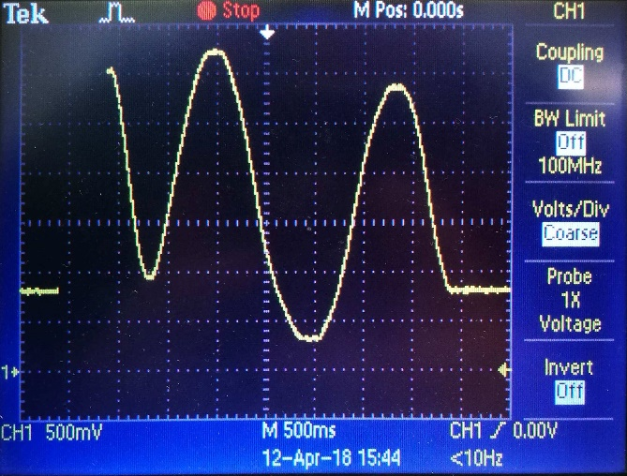

Appendix B – Gantt Chart Page 1

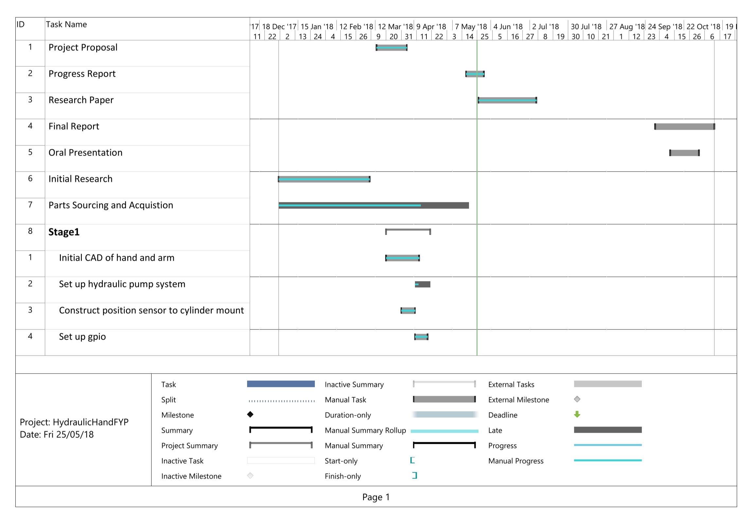

**Appendix C – Gantt Chart Page 2**

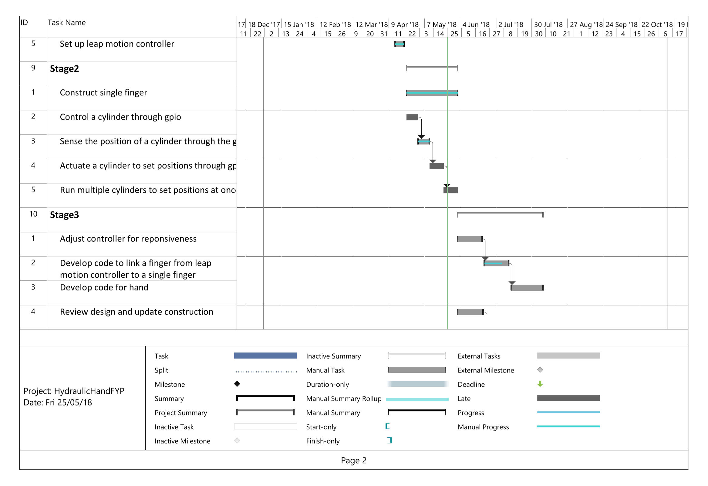

**Appendix D – Gantt Chart Page 3**

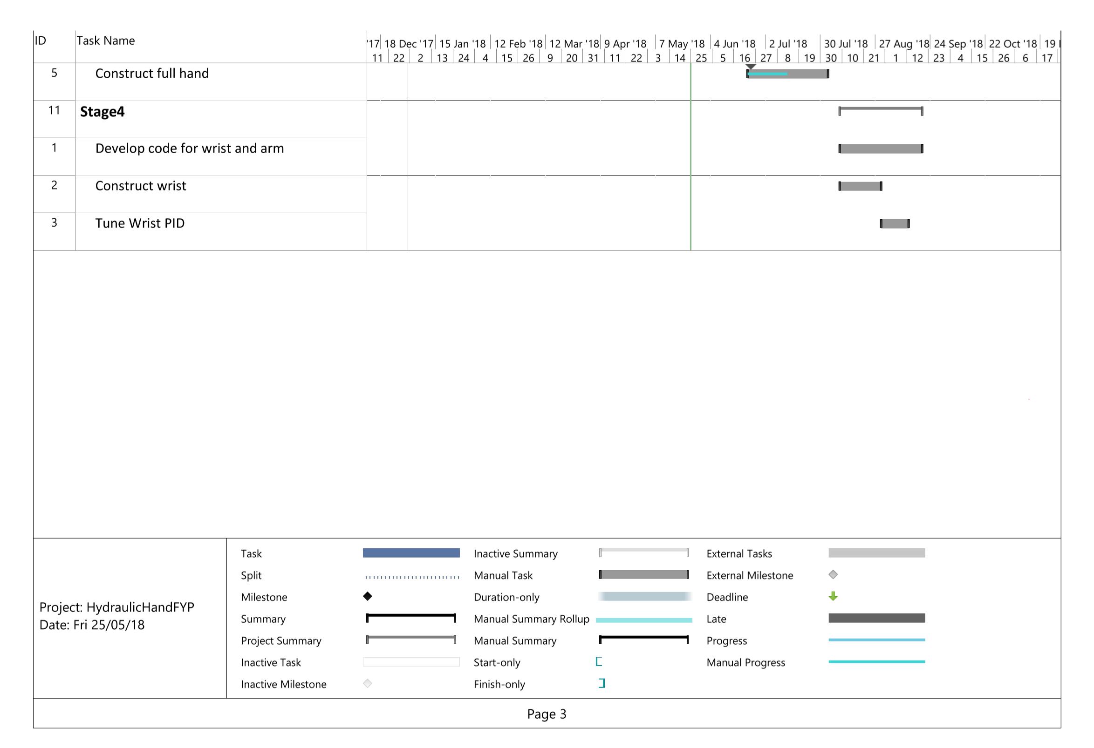

**Appendix E – Complete Hydraulic Schematic**

